**TASK 24 – MYSQL**

1. **Create a table Employee to store employee details as shown below and write statements for following queries based on table.**

**Step 1 : Create Database**

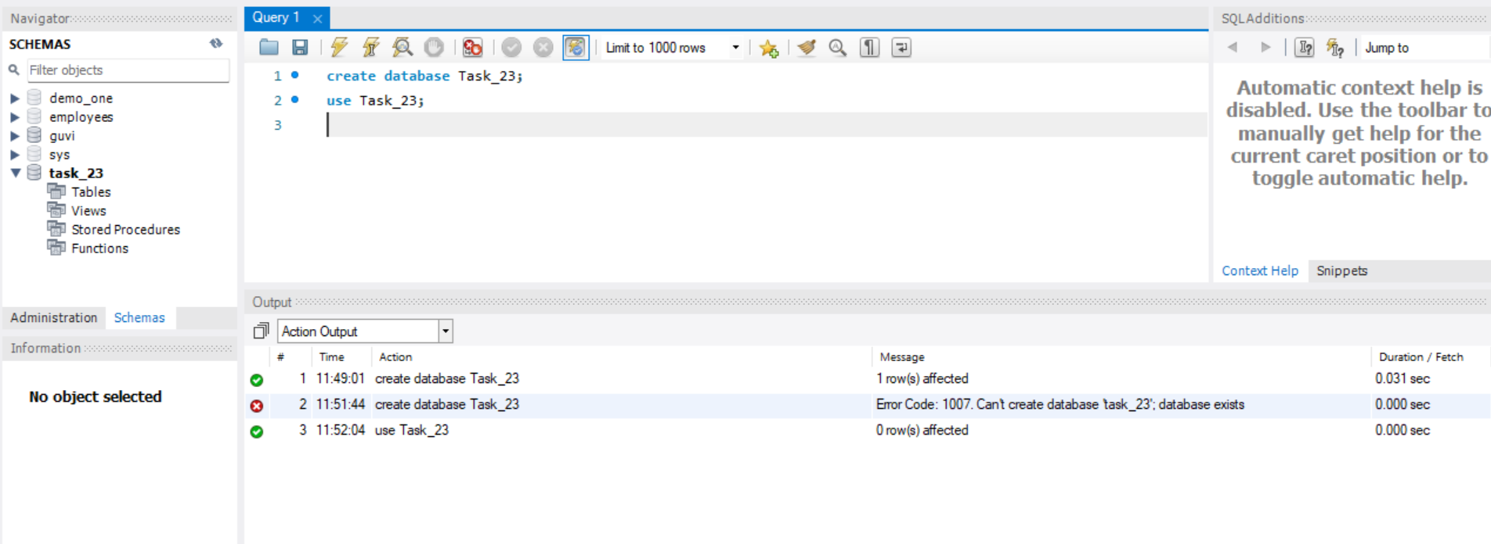

**Step 2: Create Employee table**

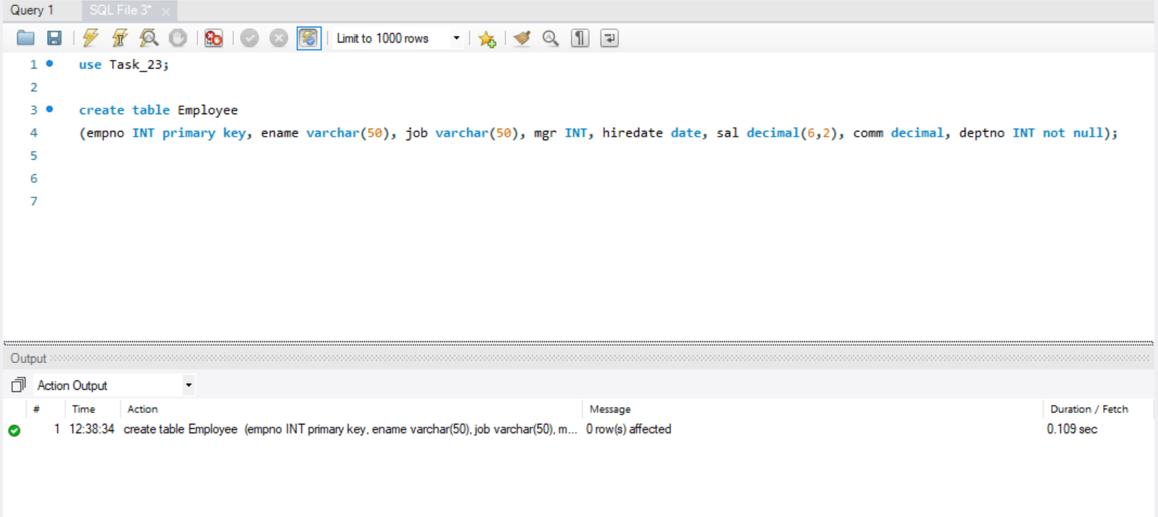

After refreshing, the table gets reflected in the database

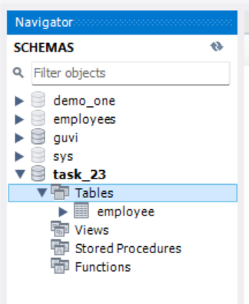

**Step 3 : Insert values in the table**

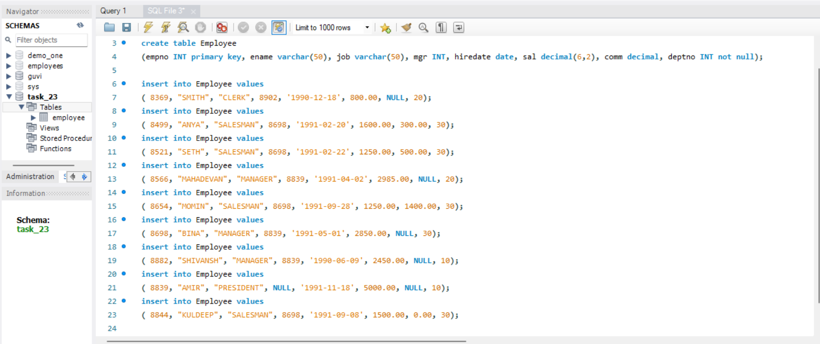

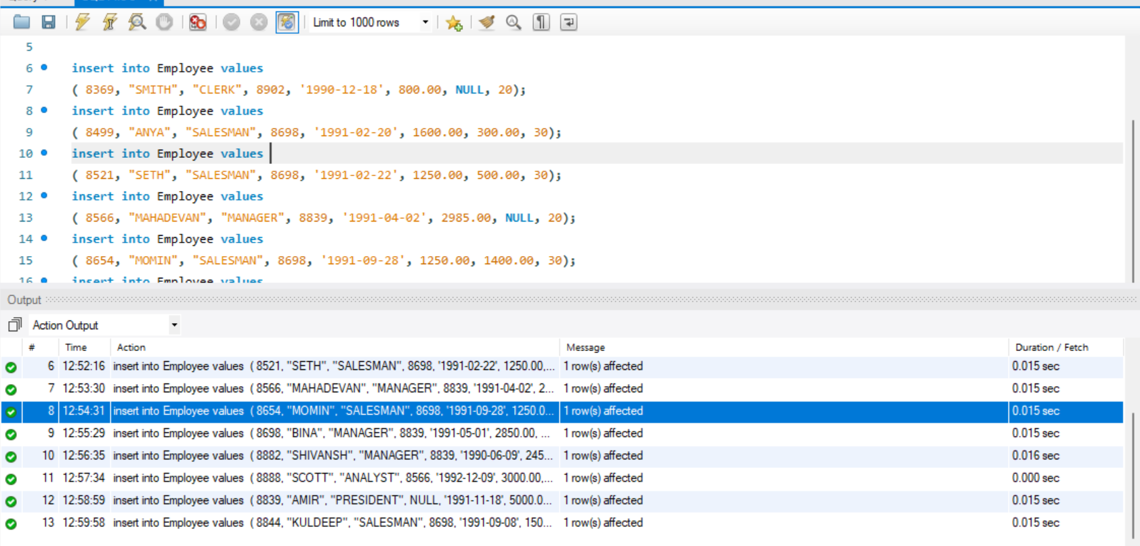

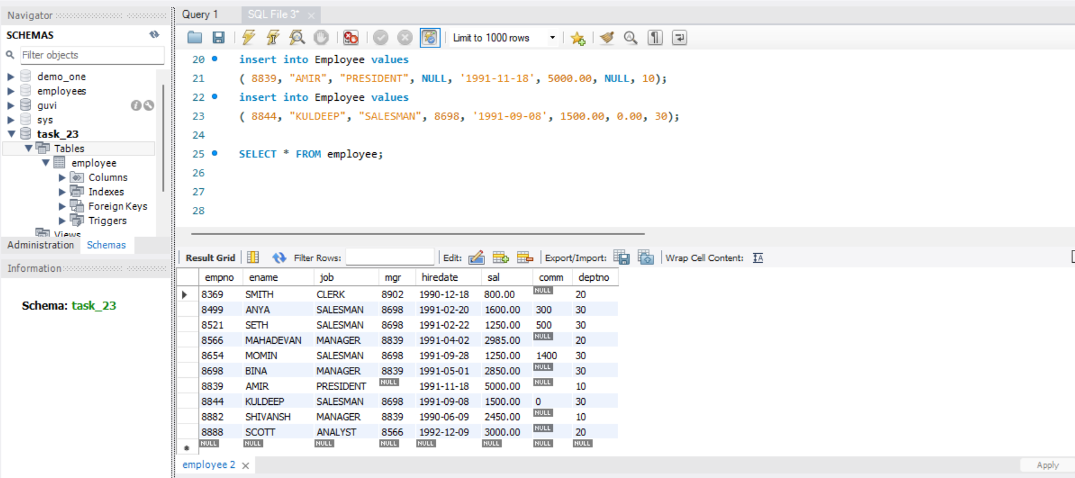

**QUERIES :**

**Consider the Employee table and write SQL command to get the following :**

1. Write a query to display ename and sal of employees whose salary are greater than or equal to 2200?

**select ename, sal from employee where sal>= 2200;**

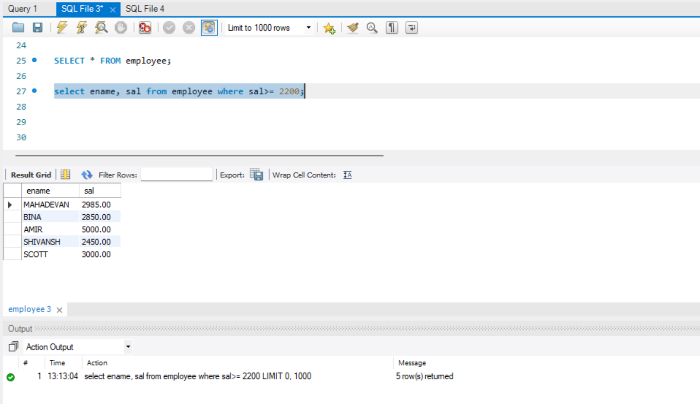

1. Write a query to display details of employees who are not getting commission?

**select * from employee where comm is NULL;**

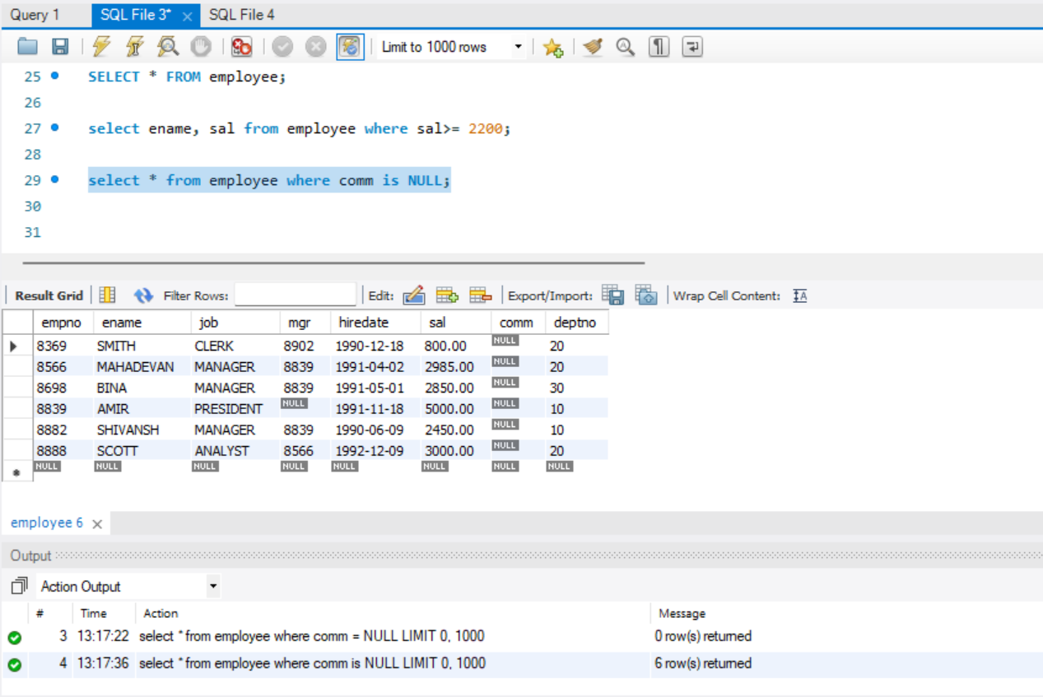

1. Write a query to display employee name and salary of those employees who don’t have their salary in the range of 2500 to 4000.

**select ename, sal from employee where sal NOT BETWEEN 2500 and 4000;**

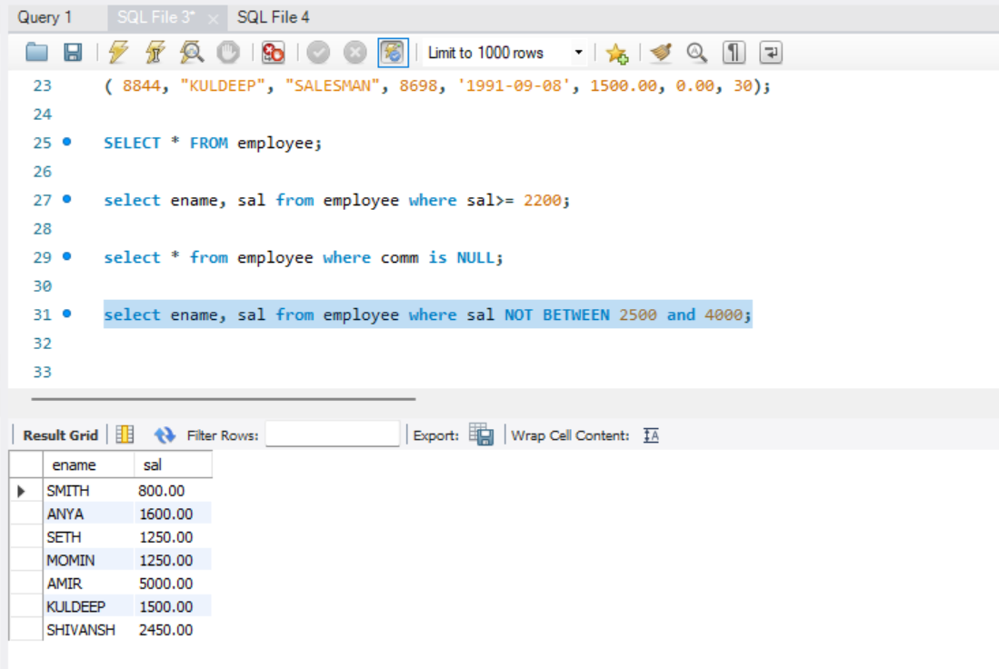

1. Write a query to display the name, job title and salary of employees who don’t have a manager.

**select ename, job, sal from employee where mgr is NULL;**

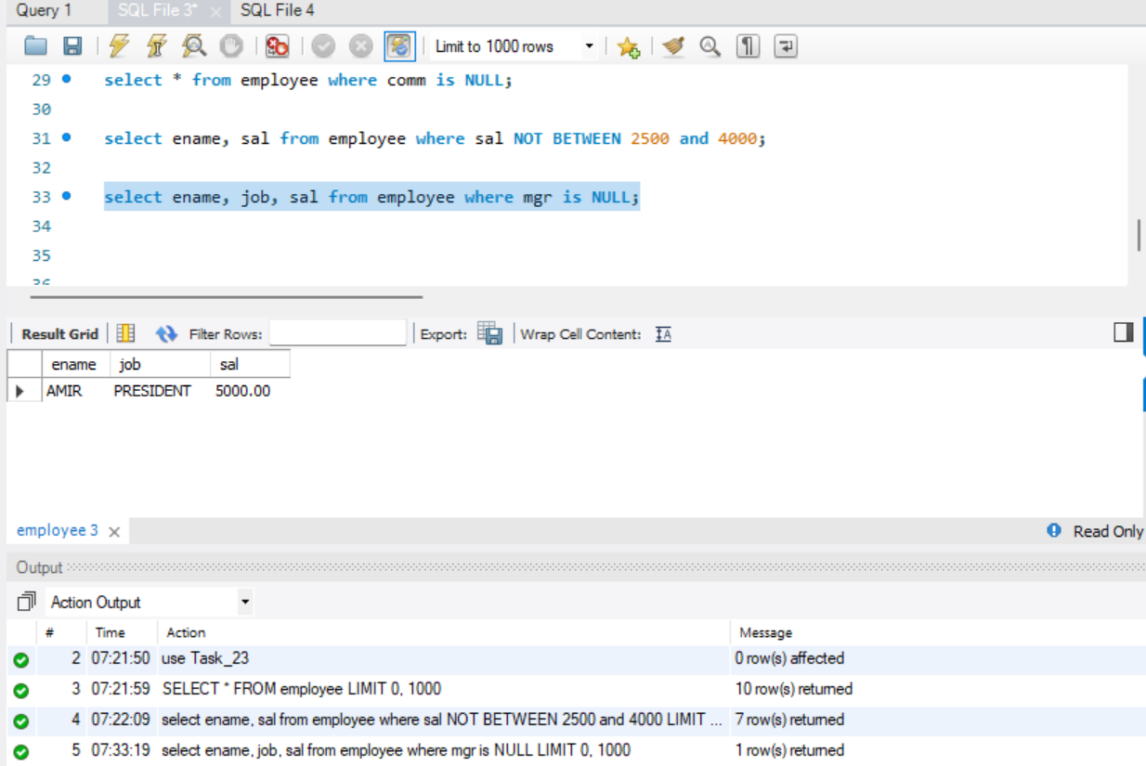

1. Write a query to display the name of an Employee whose names contains “A” as third alphabet?

**select ename from employee where ename like ‘__a%’;**

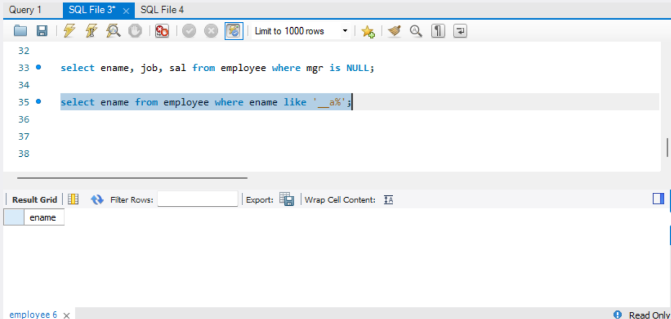

1. Write a query to display the name of an Employee whose name contains “T” as the last alphabet.

**select ename from employee where ename like ‘%t’;**

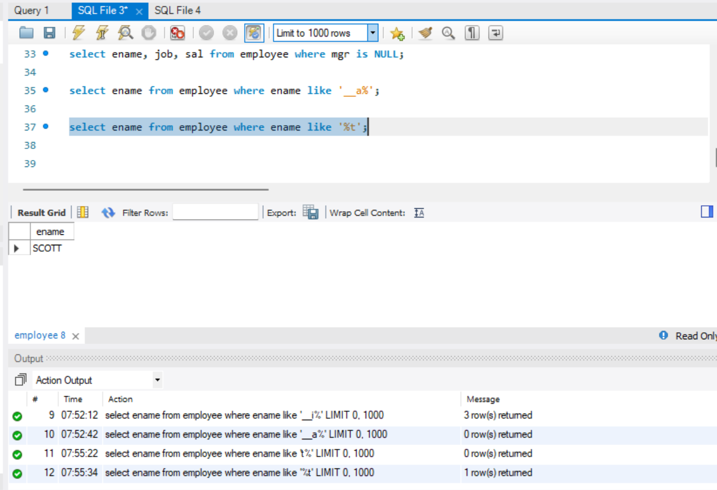

**Queries created in SQL workbench for reference :**

create database Task_23;

use Task_23;

create table Employee

(empno INT primary key, ename varchar(50), job varchar(50), mgr INT, hiredate date, sal decimal(6,2), comm decimal, deptno INT not null);

insert into Employee values

( 8369, "SMITH", "CLERK", 8902, '1990-12-18', 800.00, NULL, 20);

insert into Employee values

( 8499, "ANYA", "SALESMAN", 8698, '1991-02-20', 1600.00, 300.00, 30);

insert into Employee values

( 8521, "SETH", "SALESMAN", 8698, '1991-02-22', 1250.00, 500.00, 30);

insert into Employee values

( 8566, "MAHADEVAN", "MANAGER", 8839, '1991-04-02', 2985.00, NULL, 20);

insert into Employee values

( 8654, "MOMIN", "SALESMAN", 8698, '1991-09-28', 1250.00, 1400.00, 30);

insert into Employee values

( 8698, "BINA", "MANAGER", 8839, '1991-05-01', 2850.00, NULL, 30);

insert into Employee values

( 8882, "SHIVANSH", "MANAGER", 8839, '1990-06-09', 2450.00, NULL, 10);

insert into Employee values

( 8839, "AMIR", "PRESIDENT", NULL, '1991-11-18', 5000.00, NULL, 10);

insert into Employee values

( 8844, "KULDEEP", "SALESMAN", 8698, '1991-09-08', 1500.00, 0.00, 30);

SELECT * FROM employee;

select ename, sal from employee where sal>= 2200;

select * from employee where comm is NULL;

select ename, sal from employee where sal NOT BETWEEN 2500 and 4000;

select ename, job, sal from employee where mgr is NULL;

select ename from employee where ename like '__a%';

select ename from employee where ename like '%t';

Contd…….

1. Write a program for JDBC to connectivity and insert the below data

Java Code : Github link - <https://github.com/Nandhitha096/Task23.git>

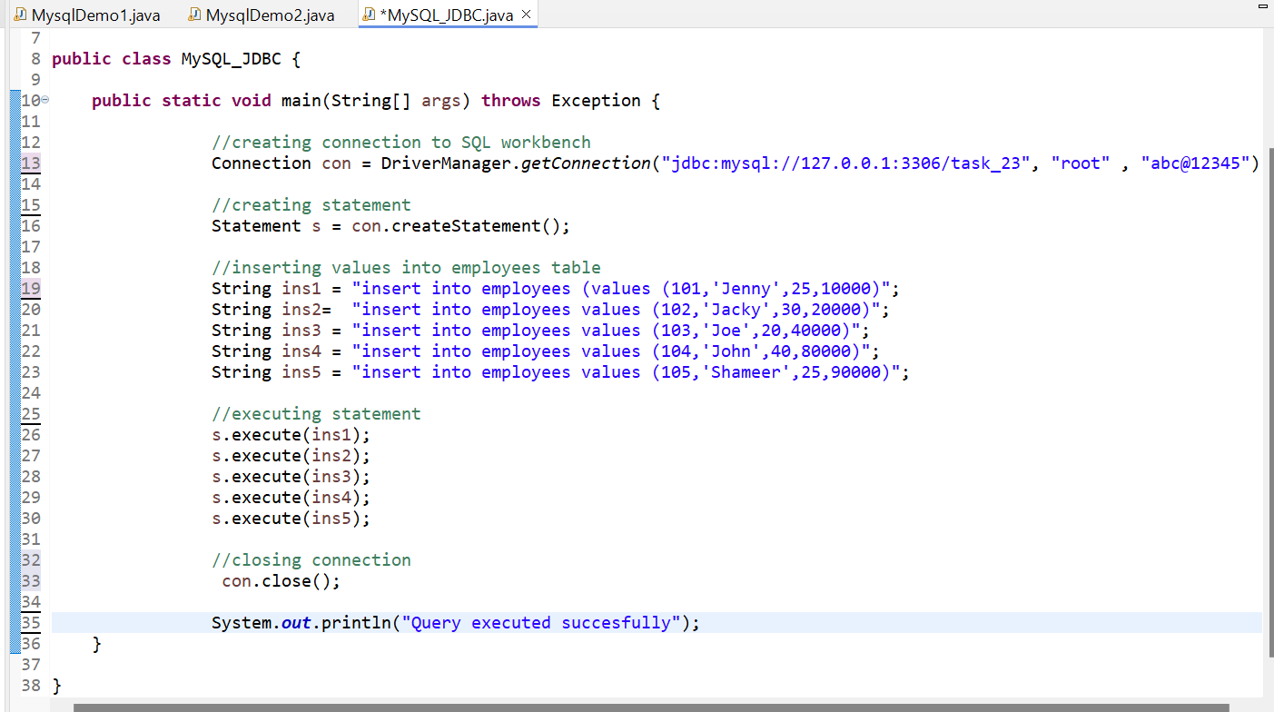

Output :

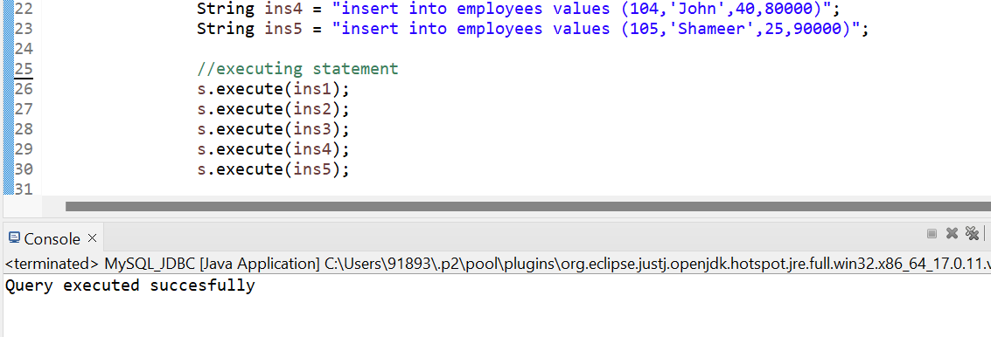

Contd….

SQL workbench :

